

*Water Resources Research*

Supporting Information for

**Resolve the clear-sky continuous diurnal cycle of high-resolution ECOSTRESS Evapotranspiration and Land Surface Temperature**

Jiaming Wen1,*, Joshua B. Fisher2, Nicholas C. Parazoo3, Leiqiu Hu4, Marcy E. Litvak5, Ying Sun1,*

1School of Integrative Plant Science, Soil and Crop Sciences Section, Cornell University, Ithaca, NY, USA.

2Schmid College of Science and Technology, Chapman University, Orange, CA, 92866, USA.

3Jet Propulsion Laboratory, California Institute of Technology, Pasadena, CA, USA.

4Department of Atmospheric and Earth Science, University of Alabama in Huntsville, AL, USA

5Department of Biology, University of New Mexico, Albuquerque, NM, USA

**Contents of this file**

Figures S1 to S10

**Introduction**

This supporting information entails figures for rainfall/cloud data at US-Seg (Fig. S1), other meteorological data (i.e., Rn, Tair, VPD, RH) from tower and MERRA-2 at US-Seg and US-ARM (Fig. S2-S5), comparison between GOES and ECOSTRESS LST (Fig. S6), soil water content measurements during the first time window at US-Seg (Fig. S7), LST and ET uncertainty (Fig. S8 and S9), and animations of constructed LST and ET (Fig. S10).

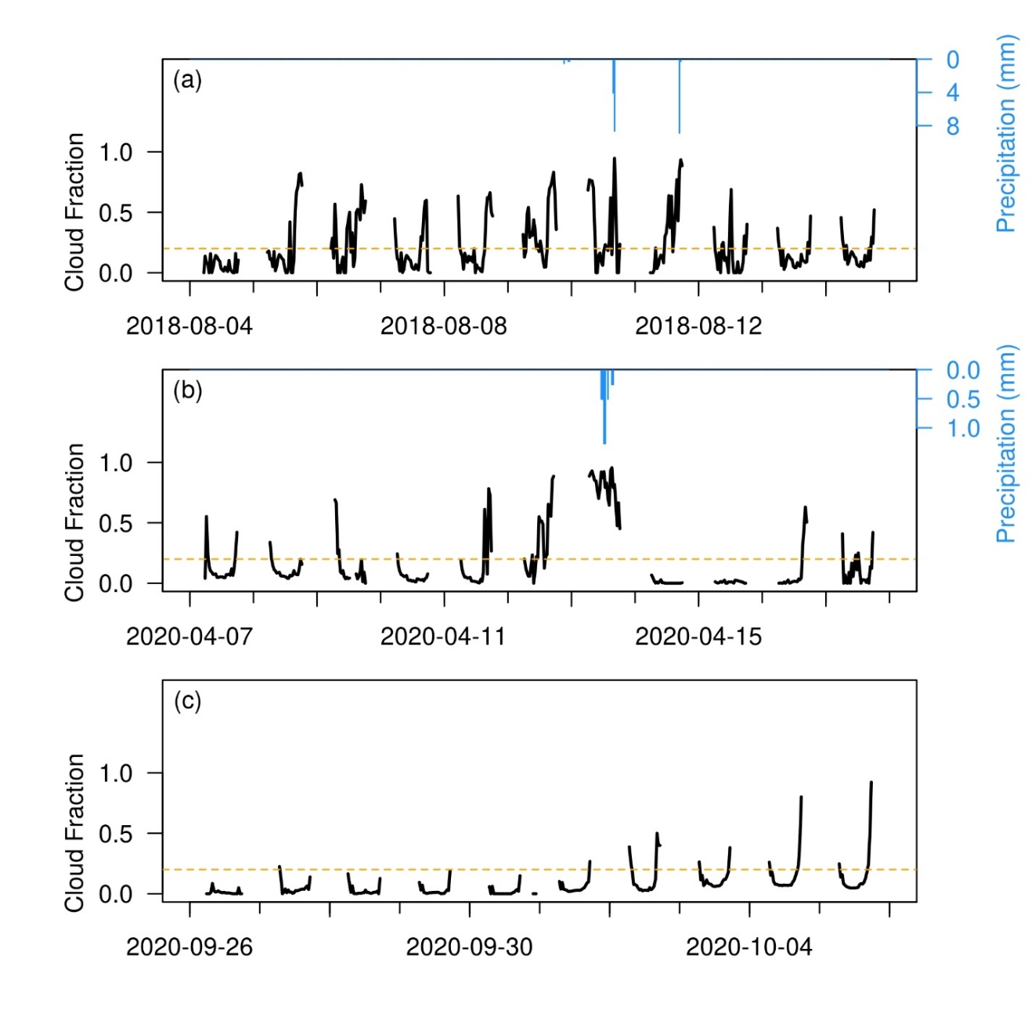

**Figure S1.** Precipitation (the right ordinates) and cloud fraction (the left ordinates, calculated by Eq. 13) at US-Seg during (a) 4-14 August 2018, (b) 7-17 April 2020, and (c) 26 September to 5 October 2020. The dash orange line represents the cutoff (cloud fraction = 0.2) between clear-sky and cloudy conditions.

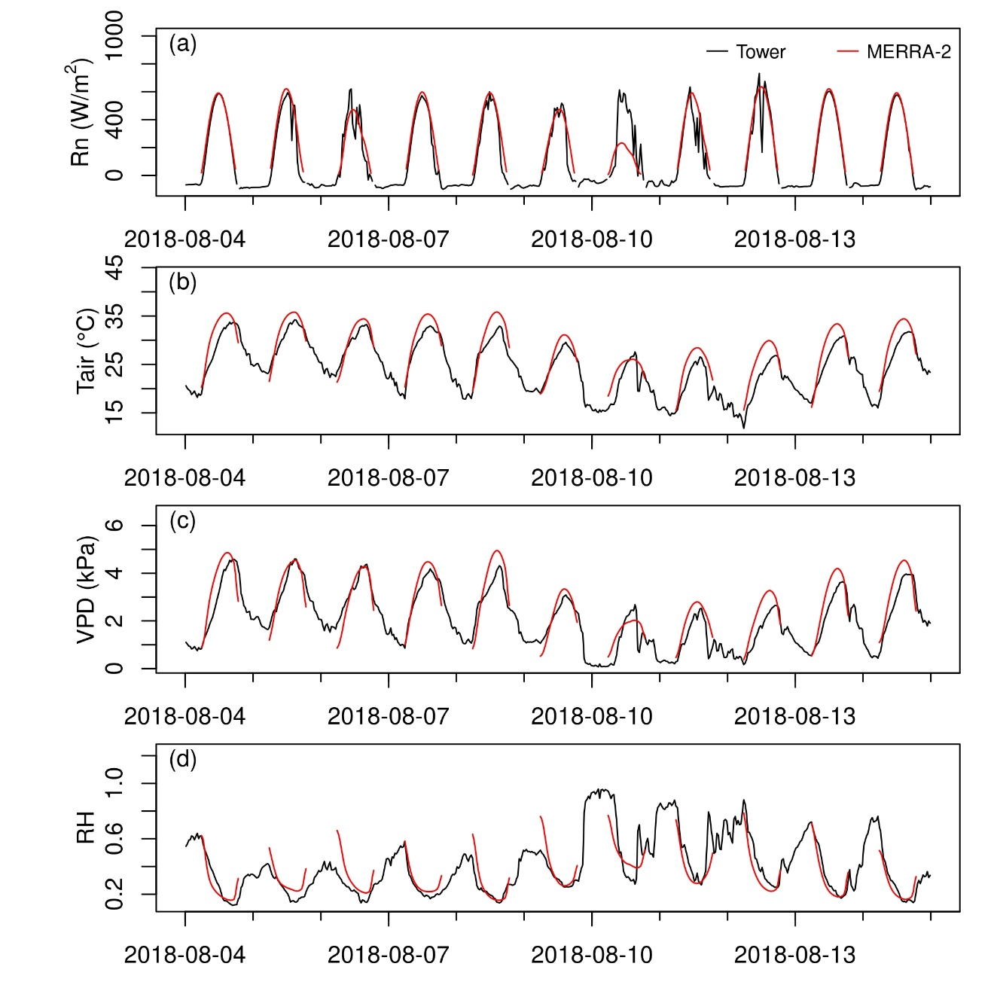**Figure S2.** Comparison of (a) net radiation (Rn), (b) air temperature (Ta), (c) vapor pressure deficit (VPD) and (d) relative humidity (RH) between MERRA-2 and tower measurements at US-Seg during 4-14 August 2018. Only daytime data is plotted for MERRA-2.

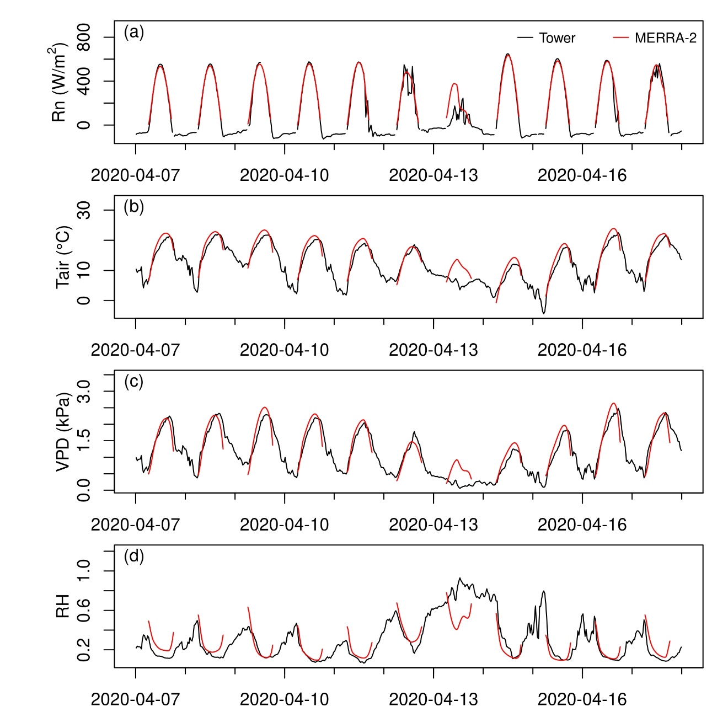**Figure S3.** Same as Fig. S2 but for the time window during 7-17 April 2020.

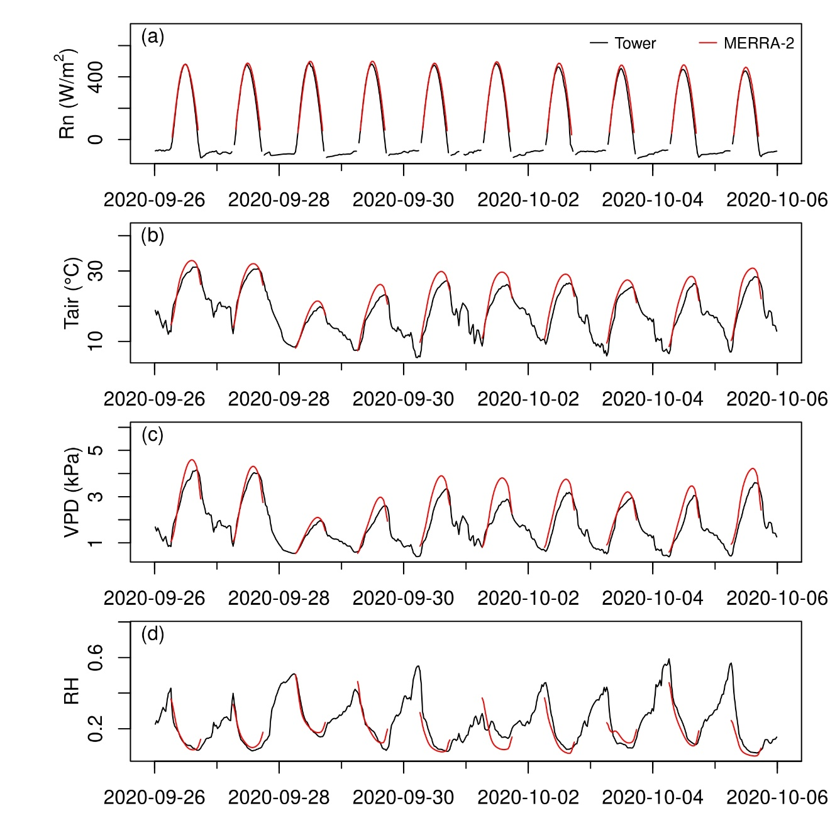**Figure S4.** Same as Fig. S2 but for the time window from 26 September to 5 October 2020.

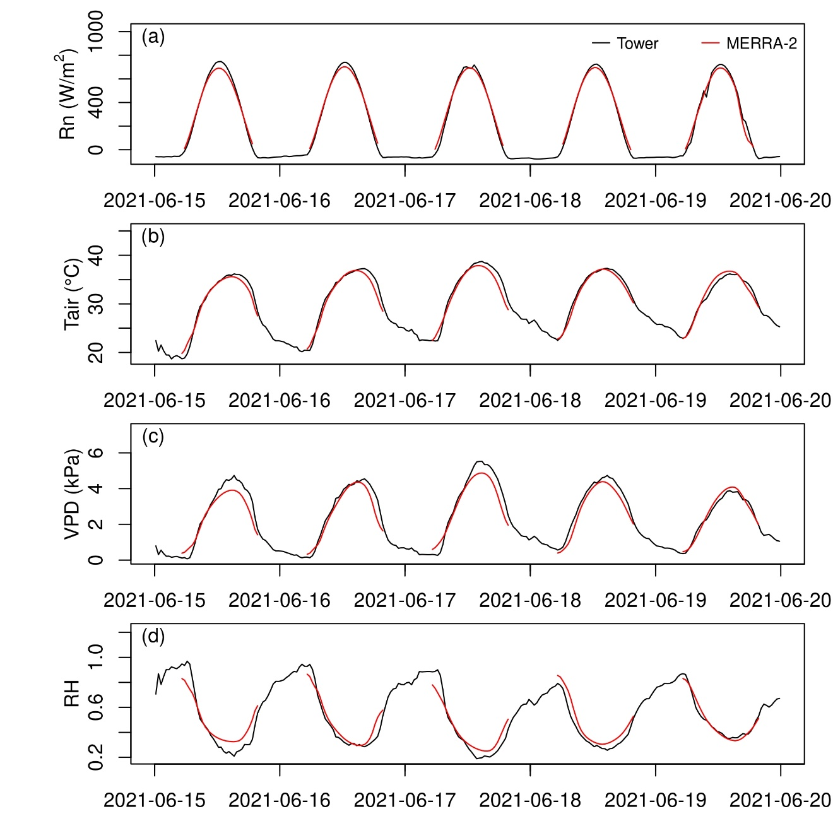 **Figure S5.** Same as Fig. S2 but for the time window during 15-19 June 2021 at US-ARM.

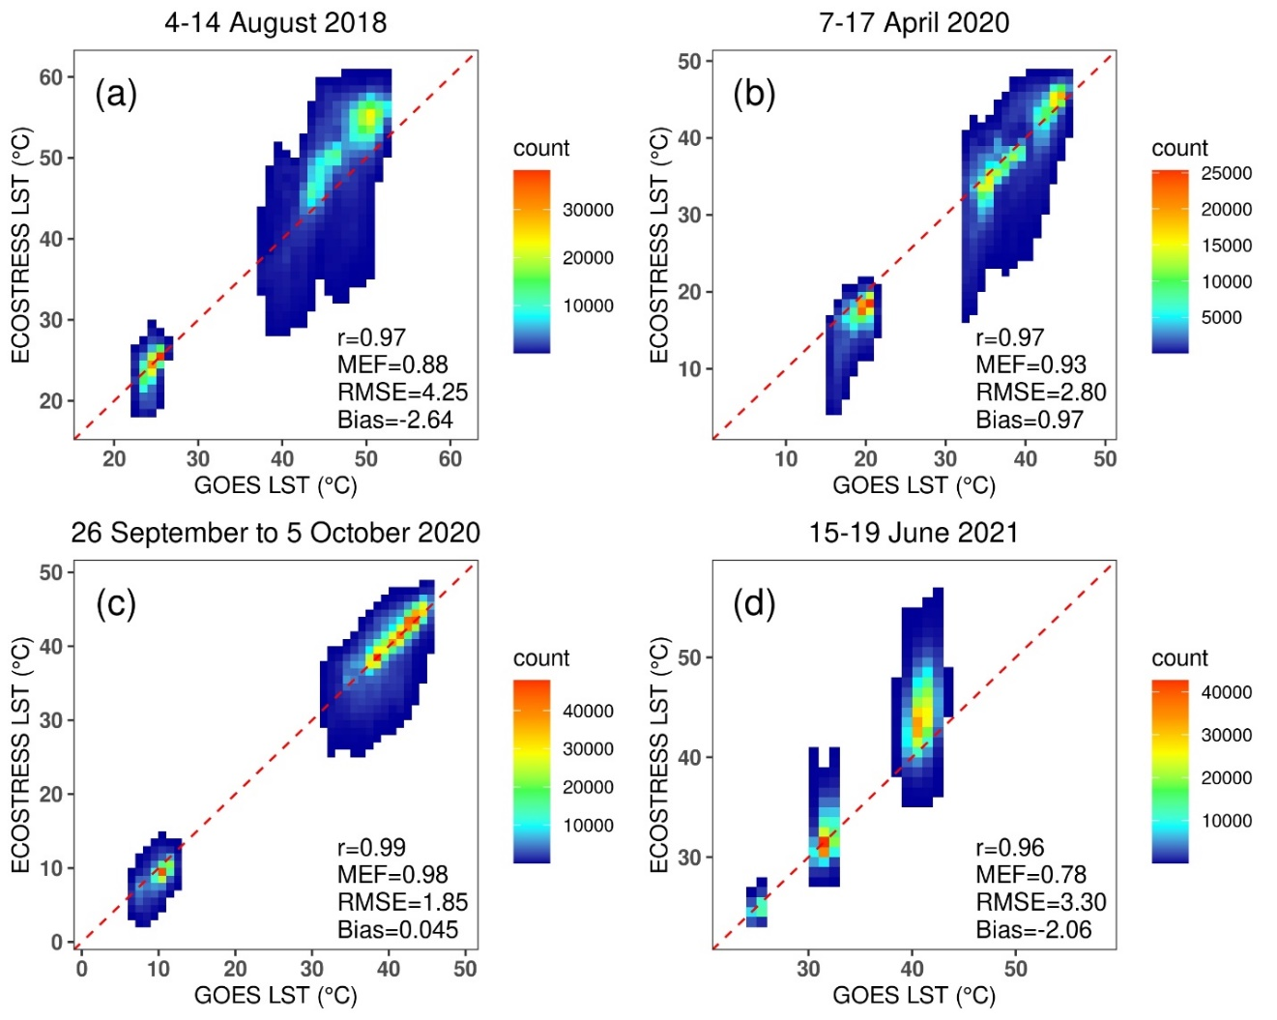**Figure S6.** Comparison between the GOES LST (interpolated spatially and temporally, y axis) and the ECOSTRESS (x axis) pooled from all the pixels and all the overpasses of each time window: (a) 4-14 August 2018, (b) 7-17 April 2020, (c) 26 September to 5 October 2020 for the domain centered at US-Seg; (d) 15-19 June 2021 for the domain centered at US-ARM. Different colors indicate scatter density. The red dashed line is 1:1 line. The statistics are calculated for GOES LST using ECOSTRESS LST as reference.

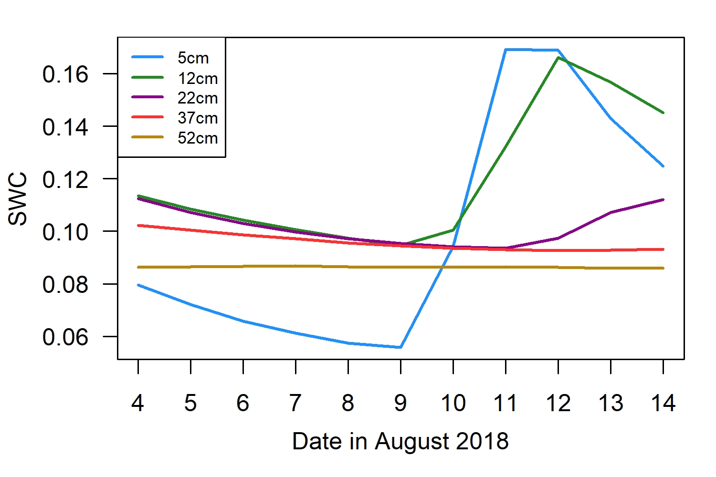

**Figure S7.** *In situ* soil water content (SWC) measurements for five depths during 4-14 August 2018 at US-Seg.

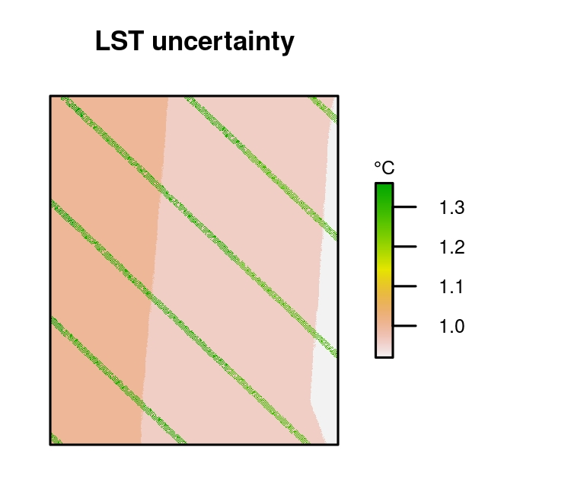

**Figure S8.** ECOSTRESS LST uncertainty of the overpass on 27 September 2020, 14:56 in local time in the 0.3°×0.3° domain centered at US-Seg (same overpass as in Fig. 5).

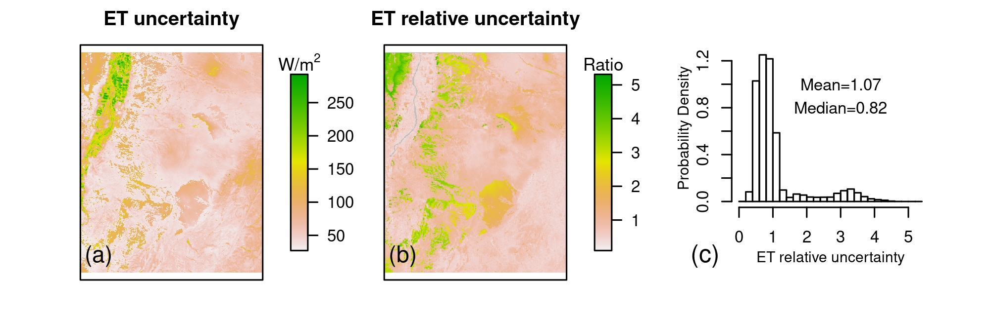**Figure S9.** ECOSTRESS ET uncertainty of the overpasses on 7 August 2018, 13:20 in local time in the 0.3°×0.3° domain centered at US-Seg (same overpass as in Fig. 9). (a) ECOSTRESS ET uncertainty, calculated as the standard deviation of ET calculation from the PT-JPL model and two other physics-based models (Mu et al., 2007, 2011; Su 2002); (b) ET relative uncertainty, calculated as the ratio of (a) and ECOSTRESS ET (Fig. 9a); (c) histogram of (b).

**Figure S10.** The full hourly time series of (a) LST and (b) ET mapping in the test domain centered at US-Seg during 26 September and 5 October 2020. Please refer to the Supplementary Data for full animation.